Topic: AI In Healthcare
(Diagnosis and treatment)
Course code: INT 404

Submitted To: Ankita Wadhawan LOVELY PROFESSIONAL UNIVERSITY
PHAGWARA, PUNJAB



SUBMITTED BY:

Name: Subhash Bhambu Registration no.: 12104813

Name: Atul Mahalan
Registration no : 12108213

ABSTRACT :-

The purpose of Artificial Intelligence is to make computers more useful in solving problematic healthcare challenges and by using computers we can interpret data which is obtained by diagnosis of various chronic diseases like Alzheimer, Diabetes, Cardiovascular diseases and various types of cancers like breast cancer, colon cancer etc.

It helps in early detection of various chronic diseases which reduces economic burden and severity of disease. Various automated systems and tools like Brain-computer interfaces (BCIs), arterial spin labeling (ASL) imaging, ASL-MRI, biomarkers, IT bra, Natural language processing (NLP)and various algorithms helps to minimize errors and control disease progression.

The computer assisted diagnosis, decision support systems, expert systems and implementation of software may assist physicians to minimize the intra and inter-observer variability.
To streamline the process of diagnosis artificial intelligence methods specifically artificial neural networks (ANN), Fuzzy approach can be implemented to handle diverse type of medical data.

ANN technique discovers the hidden patterns and correlation in medical data and effective in designing support system in clinical field.

The application of AI facilitates interpretation of results with high accuracy and speed. This review will explore how artificial intelligence and machine learning can save lives by helping individual patients beat the odds.

OBJECTIVE: -

Artificial Intelligence or AI technology is gaining popularity worldwide. It is being used in big organizations as well as our daily lives. Now, taking one step forward, AI is developed to prove useful in the healthcare industry. In simple terms, all the data from diagnosis will be collected and then used for understanding the diseases, so that they can be treated with more success rate.
Also, it will ease the life of patients. They will have a digital record that will be accessible to doctors. This way, they can get healthcare advice by sitting at home. Doctors who access the records might want to change them. So, they can do it easily. Also, it will provide security to the personal data of people.

The primary objective of an AI-based healthcare diagnosis and treatment project is to develop an intelligent system that can accurately diagnose and treat medical conditions with high precision and efficiency. The system will utilize machine learning algorithms to analyze large amounts of patient data to identify patterns, predict diagnoses, and suggest the most effective treatment plans.

USE CASES OF AI IN HEALTHCARE :

1.Analysis of medical images :
As a result of medical examinations, huge amounts of information are created. They contain a lot of graphical data that needs to be analyzed. These are MRI images, ultrasound results, cardiograms, and CT scan findings.
The process of analyzing and grouping medical images is time-consuming and labor-intensive. With the help of AI, the results of these graphic studies can be analyzed. AI technologies optimize visual information and help cardiologists and radiologists:
- provide all the advantages of an automated system for recording medical documents;
- focus on important factors in severe cases;
- help to make a more accurate diagnosis
- minimize the chance of errors.
For example, the Arterys service makes it possible to pay more attention to patient complaints, as it saves the doctor from having to study in detail the results of images, ultrasound, MRI.
Algorithms analyze a lot of data at high speed and compare it with other studies of a particular patient. As a result, patterns are well traced, implicit relationships are established.

Datasets:
NIH image gallery:
The NIH medical image datasets are a collection of medical images that have been collected and made available by the National Institutes of Health (NIH). The images in the dataset can be used to train and test algorithms for various medical image analysis tasks.
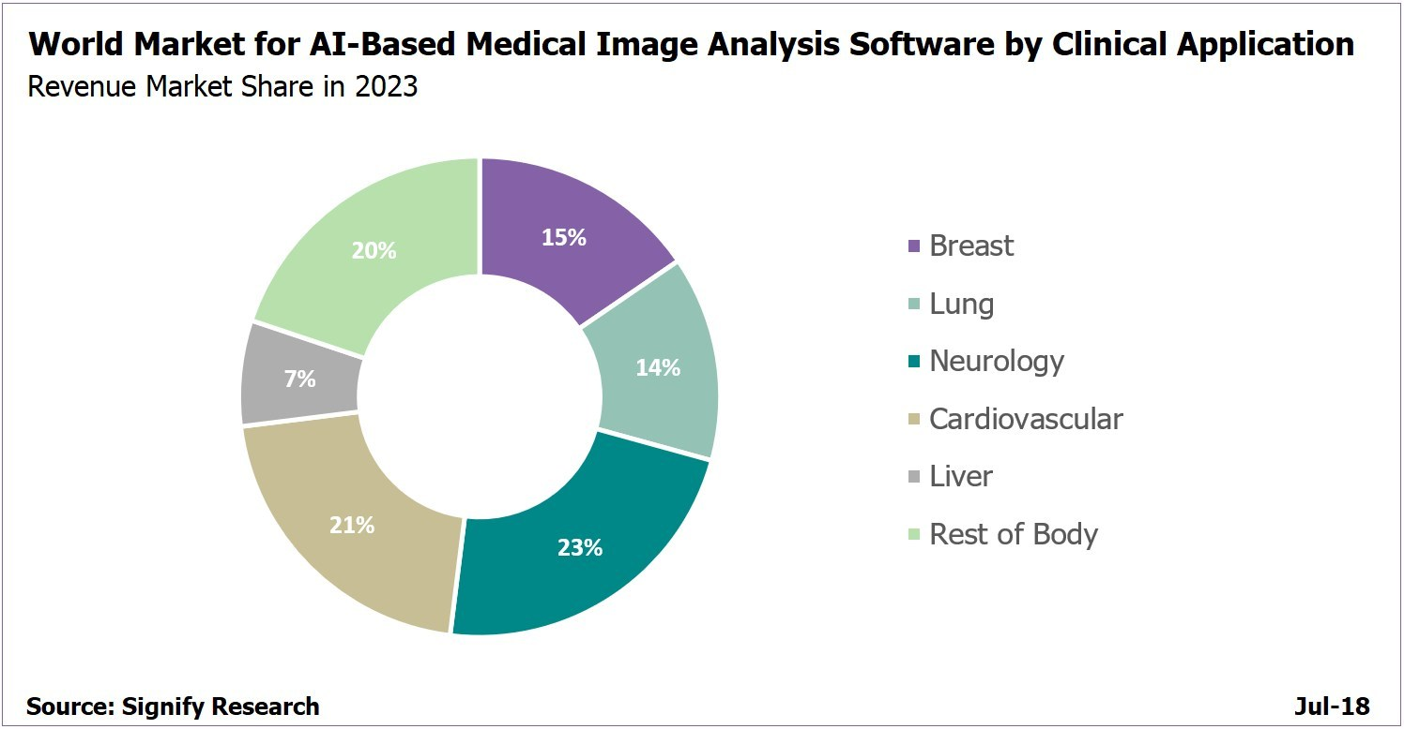

2. Applications for diagnosis and treatment:

After receiving a medical image, the diagnostician analyses it, reveals abnormalities or signs of the disease. To establish a diagnosis, the doctor must analyse several studies in a graphical form.
After machine learning, AI-based systems no longer only recognize medical graphics. They analyze medical images and report the features they find. For example, they are signal small neoplasms that the human eye may not fix. Such systems identify patterns and provide information about the characteristics of any deviations from the norm.
The diagnosis will be more accurate if the patient has several pictures taken at different times. Then the neural network will analyze the dynamics of the disease.
Datasets: Some doctors for rare childhood illnesses use IBM Watson neural network software. AI helps them make diagnoses with greater accuracy. To do this, the computer will look for relevant information in databases of clinics and medical journals. All this information is stored in the Watson Health Cloud.

Thus, every third person with a stroke receives the wrong treatment. Israel’s MedyMatch Technology has developed self-learning software to improve stroke diagnosis. To do this, MedyMatch compares the patient’s brain scan with a huge number of others that are in its database.

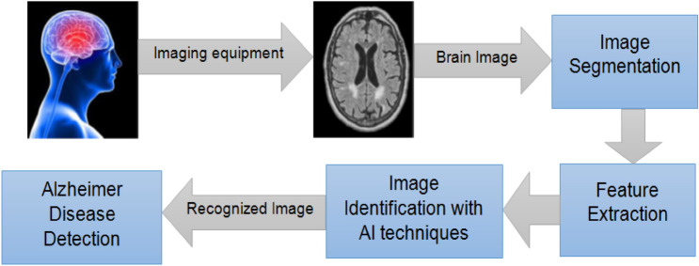

AI for In-Patient Mobility Monitoring :
The clinical staff are busy people. Take intensive care unit (ICU) nurses, for example, who often have multiple patients in critical condition under their watch. Limited mobility and cognition during long-term treatments can adversely affect the patients’ overall recovery.

Monitoring their activity is vital. To improve outcomes, researchers at Stanford University and Intermountain LDS Hospital installed depth sensors equipped with ML algorithms in patients’ rooms to keep track of their mobility. The technology accurately identified movements 87 percent of the time. Eventually, the researchers aim to provide ICU staff with notifications when patients are in trouble.

Clinical Trials for Drug Development:
One of the biggest challenges in drug development is conducting successful clinical trials. As it stands now, it can take up to 15 years to bring a new – and potentially life-saving – a drug to market, according to a report published in Trends in Pharmacological Sciences. It can also cost between $1.5 and $2 billion. Around half of that time is spent in clinical trials, many of which fail. Using AI technology, however, researchers can identify the right patients to participate in the experiments. Further, they can monitor their medical responses more efficiently and accurately — saving time and money along the way.

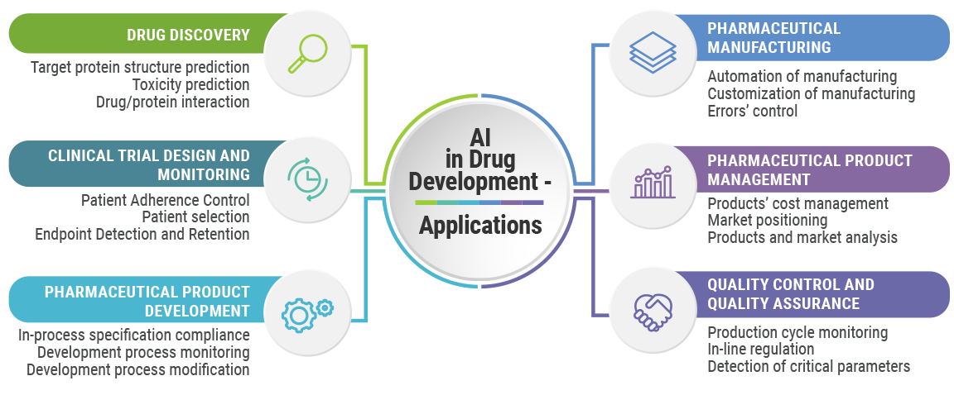

AI Can Predict Heart Attacks

Plaque is made of substances that circulate in the bloodstream, including cholesterol and fat. Over time, plaque builds up in arteries, causing them to narrow and stiffen. Similar to how sink drains can become clogged by food and debris, arteries can become clogged by plaque, restricting blood flow and leading to a heart attack or stroke.
A medical test called coronary computed tomography angiography (CTA) takes 3D images of the heart and arteries. Plaque in arteries is visible in CTA images, but measuring the amount of plaque can take an expert 25-30 minutes. So researchers at Cedars Sinai developed an AI algorithm that enables a computer to perform the same task in mere seconds.
Virtual assistants and chatbots:
AI can be used to develop virtual assistants and chatbots to provide patients with personalized advice and support. Datasets used for this purpose include the Cornell Movie-Dialogs Corpus, the Ubuntu Dialogue Corpus, and the Stanford Question Answering Dataset.

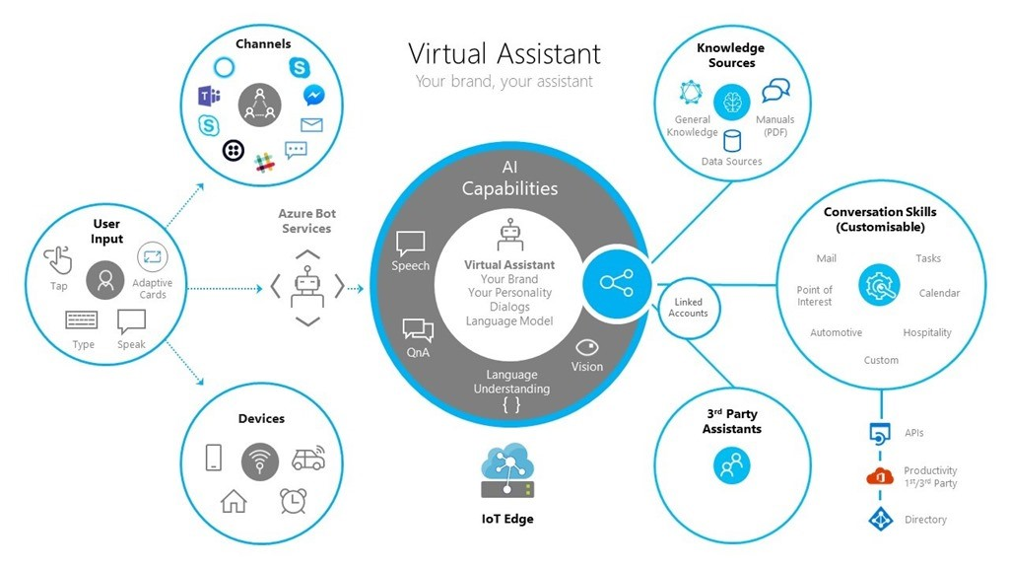

Electronic health records (EHR) analysis:
AI can be used to analyze EHR data to identify patterns and predict patient outcomes. Datasets used for this purpose include the MIMIC-III dataset, the Optum EHR dataset, and the Medicare dataset.
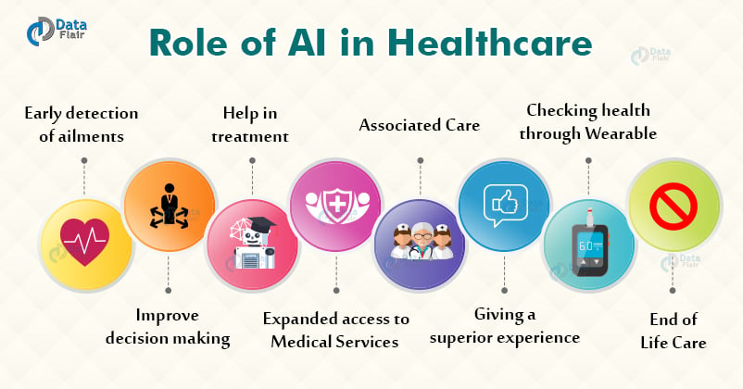

Benefits of AI in healthcare :-

Artificial intelligence (AI) is changing the healthcare industry in numerous ways. AI refers to the ability of machines to simulate human intelligence, including learning, reasoning, and perception. In healthcare, AI is being used to improve diagnosis and treatment, enhance patient monitoring and engagement, and streamline administrative tasks.

AI and Personalized Medicine

One of the most promising applications of AI in healthcare is personalized medicine. By analyzing vast amounts of patient data, AI algorithms can identify patterns and predict outcomes for individual patients. This enables doctors to create personalized treatment plans that are tailored to the patient's unique needs, resulting in better outcomes and reduced healthcare costs.

For example, AI algorithms can analyze genetic data to predict a patient's risk of developing certain diseases. This information can help doctors create personalized prevention plans that focus on lifestyle changes, screening tests, and early interventions.

AI is also being used to develop new drugs and therapies. By analyzing vast amounts of data on drug interactions and molecular structures, AI algorithms can identify promising drug candidates more quickly and accurately than traditional methods. This can help speed up the drug development process and reduce costs.

AI and Diagnosis

AI is also improving the accuracy and efficiency of diagnosis. By analyzing medical images, such as X-rays, CT scans, and MRIs, AI algorithms can identify patterns that indicate the presence of disease. This enables doctors to make more accurate diagnoses and develop treatment plans more quickly.

One example of AI's potential for diagnosis is in detecting breast cancer. A study published in the journal Nature showed that an AI algorithm was able to identify breast cancer on mammograms with greater accuracy than radiologists. The algorithm was also able to reduce the number of false positives, which can lead to unnecessary biopsies and anxiety for patients.

AI is also being used to diagnose other diseases, such as pneumonia, tuberculosis, and diabetic retinopathy. In one study, an AI algorithm was able to accurately diagnose pneumonia from chest X-rays with greater accuracy than radiologists. This could be especially helpful in developing countries where access to trained radiologists is limited.

AI and Patient Monitoring

Another important application of AI in healthcare is patient monitoring. AI-powered devices can track patient health metrics, such as blood pressure, heart rate, and glucose levels, and alert doctors when there are changes that may require intervention.

This can be especially helpful for patients with chronic conditions who need ongoing care.
For example, an AI-powered wearable device could monitor a patient's heart rate and blood pressure and send alerts to the patient's doctor if there are any irregularities. This enables doctors to intervene early and prevent serious complications.

AI is also being used to improve patient engagement and adherence to treatment plans. By analyzing patient data and providing personalized feedback, AI-powered apps and devices can help patients stay motivated and on track with their treatment plans. This can lead to better health outcomes and reduce healthcare costs by preventing complications and hospital readmissions.

AI and Administrative Tasks

AI is also being used to streamline administrative tasks in healthcare, such as scheduling appointments, managing electronic health records (EHRs), and processing insurance claims. This can help reduce costs and improve the efficiency of healthcare delivery.

For example, AI algorithms can analyze EHRs to identify patients who are at high risk for readmission. This enables doctors to intervene early and prevent readmissions, which can be costly for both patients and healthcare providers.

AI is also being used to improve the efficiency of clinical trials. By analyzing vast amounts of patient data, AI algorithms can identify patient populations that are most likely to benefit from a particular drug or therapy. This can help reduce the time and cost of clinical trials and accelerate the development of new treatments.

AI and Ethics

While AI has the potential to transform healthcare, it also raises important ethical and legal questions. For example, there are conc erns about the accuracy and fairness of AI
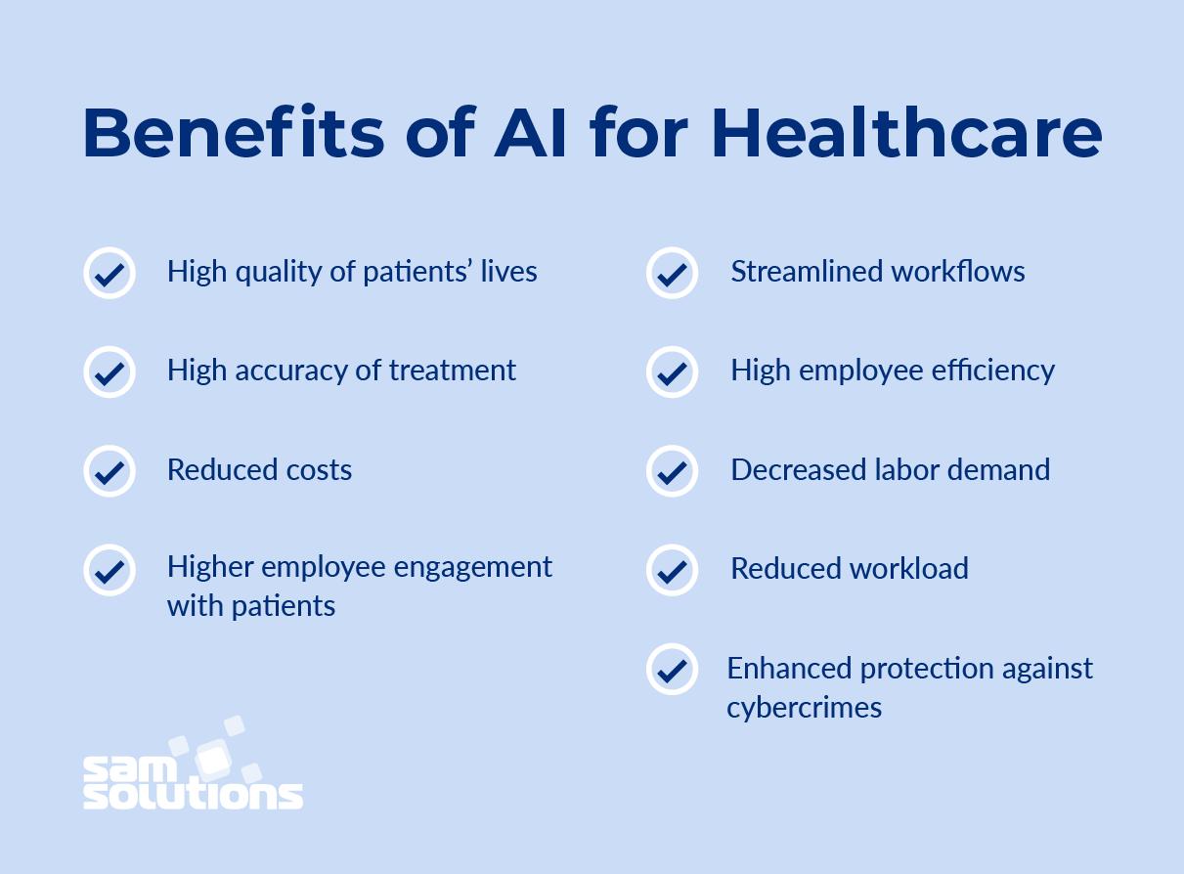

Diagnosis and Treatment Applications
Diagnosis and treatment of disease has been at the core of artificial intelligence AI in healthcare for the last 50 years. Early rule-based systems had potential to accurately diagnose and treat disease, but were not totally accepted for clinical practice. They were not significantly better at diagnosing than humans, and the integration was less than ideal with clinician workflows and health record systems.

But whether rules-based or algorithmic, using artificial intelligence in healthcare for diagnosis and treatment plans can often be difficult to marry with clinical workflows and EHR systems. Integration issues into healthcare organizations has been a greater barrier to widespread adoption of AI in healthcare when compared to the accuracy of suggestions.

Much of the AI and healthcare capabilities for diagnosis, treatment and clinical trials from medical software vendors are standalone and address only a certain area of care. Some EHR software vendors are beginning to build limited healthcare analytics functions with AI into their product offerings, but are in the elementary stages. To take full advantage of the use of artificial intelligence in healthcare using a standalone EHR system providers will either have to undertake substantial integration projects themselves, or leverage the capabilities of third party vendors that have AI capabilities and can integrate with their EHR.

Various ways AI can be used for Diagnosis and Treatment:

Artificial Intelligence (AI) has the potential to revolutionize healthcare by enabling more accurate and efficient diagnosis and treatment. The use of AI in healthcare has become increasingly popular in recent years, as it provides a range of benefits, such as improving patient outcomes, reducing healthcare costs, and enhancing the overall quality of care.

Now, we will explore the various ways in which AI can be used in healthcare, with a focus on diagnosis and treatment applications.

1. Medical Imaging: One of the most common applications of AI in healthcare is medical imaging. AI can analyse medical images such as X-rays, CT scans, and MRIs, to help physicians detect abnormalities, tumors, and other diseases with greater accuracy. AI algorithms can highlight potential issues that human eyes might miss, enabling earlier diagnosis and intervention.

For example, AI can help radiologists to detect breast cancer. AI algorithms can analyse mammograms to identify patterns and anomalies that might be missed by human radiologists. This can improve the accuracy of breast cancer detection and lead to earlier treatment, which can improve patient outcomes.

2. Predictive Analytics: AI can be used to analyse electronic health records (EHRs) and predict patient outcomes, such as identifying high-risk patients who may be more susceptible to certain diseases. AI algorithms can also analyse patient data to determine the best treatment plan, which can help physicians make more informed decisions.

For example, AI can help to predict which patients are most likely to be readmitted to the hospital after discharge. By analysing patient data, such as age, medical history, and medication usage, AI algorithms can identify patients who are at high risk of readmission. This can help healthcare providers to take preventive measures, such as adjusting medication dosages or providing additional support after discharge, to reduce the likelihood of readmission.

3. Drug Discovery: AI can assist in the discovery of new drugs and treatments by analysing vast amounts of data and identifying patterns that may be useful in developing new therapies. AI algorithms can also help researchers identify potential side effects and contraindications.

For example, AI can be used to analyse drug interactions and identify potential adverse reactions. By analysing data from clinical trials and patient records, AI algorithms can identify patterns and correlations that might indicate a potential problem. This can help pharmaceutical companies to develop safer and more effective drugs.

4. Virtual Nursing Assistants: AI can provide virtual nursing assistance for patients with chronic conditions, such as diabetes, by monitoring symptoms and medication adherence. This can improve patient outcomes and reduce healthcare costs by preventing hospital readmissions.

For example, AI can be used to monitor blood sugar levels in patients with diabetes. By analysing data from continuous glucose monitors (CGMs), AI algorithms can detect patterns and trends that might indicate a problem, such as a sudden increase in blood sugar levels. This can alert healthcare providers to take action, such as adjusting medication dosages or providing additional support, before the patient experiences a serious complication.

5. Robotics-Assisted Surgery: AI can assist surgeons by providing real-time feedback during surgeries, and by helping to guide surgical instruments with greater precision. This can reduce the risk of human error and improve patient outcomes.

For example, AI can be used to guide surgical robots during minimally invasive surgeries. By analysing data from imaging systems, such as X-rays or CT scans, AI algorithms can help the surgical robot to navigate the patient's body with greater accuracy. This can reduce the risk of complications and lead to faster recovery times for patients.

In addition to these applications, AI can also be used to improve the overall quality of care by reducing administrative tasks and improving communication between healthcare providers. For example, AI can be used to automate routine administrative tasks, such as appointment scheduling and medical record-keeping, freeing up healthcare providers to focus on patient care.

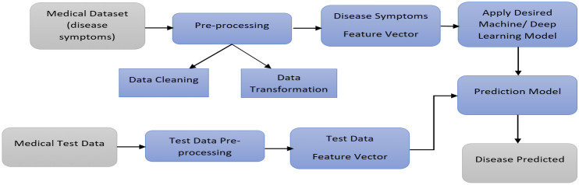

Disadvantages of AI in Healthcare:-

Artificial Intelligence (AI) has the potential to revolutionize the healthcare industry, improving patient outcomes, streamlining workflows, and reducing costs. However, there are also significant drawbacks and concerns that need to be addressed. In this note, we will explore the disadvantages of AI in healthcare in more detail.

Lack of Transparency:
One of the most significant drawbacks of AI in healthcare is the lack of transparency in how it makes decisions. Many AI algorithms are considered to be "black boxes," meaning that it is difficult or impossible to understand how they arrive at a particular decision or recommendation.

This lack of transparency can be problematic for patients and providers who may be unsure about whether to trust the algorithm's output.

Bias:
Another major concern with AI in healthcare is the potential for bias. AI algorithms are only as good as the data they are trained on, and if that data is biased, then the algorithm's output may also be biased. This can lead to unfair or inaccurate diagnoses and treatments for certain patient populations. For example, if an AI algorithm is trained on data that is predominantly

from white patients, it may not perform as well for patients from other racial or ethnic groups.

Data Privacy and Security:
AI algorithms rely on vast amounts of data to make predictions and recommendations. This data often includes sensitive personal health information, which raises concerns about data privacy and security. If this data is not properly protected, it could be vulnerable to cyberattacks or unauthorized access, potentially leading to identity theft or other forms of harm.

Cost:
Implementing AI technology in healthcare can be expensive, especially for smaller healthcare organizations. The cost of acquiring and maintaining AI systems can be prohibitive, and there may also be costs associated with training staff on how to use these systems. As a result, only larger healthcare organizations may be able to afford to implement AI technology, potentially leading to disparities in access to care.

Reliance on Technology:
As healthcare becomes more reliant on AI and other technologies, there is a risk that providers may become too reliant on these tools and overlook the importance

of human judgment and expertise. This could lead to a situation where providers rely too heavily on the output of AI algorithms, potentially leading to missed diagnoses or incorrect treatment plans.

Limited Clinical Validation:
Many AI algorithms are developed using retrospective data, which means that they may not have been tested in real-world clinical settings. This lack of validation can be problematic because it is difficult to know how an algorithm will perform in a real-world clinical setting, where patient populations and other factors may differ from the data used to train the algorithm.

Regulatory Challenges:
The use of AI in healthcare also presents regulatory challenges. For example, the U.S. Food and Drug Administration (FDA) recently issued guidelines for the development and use of AI in healthcare, but there is still much that is not yet fully understood about how AI systems should be regulated. This lack of clear
guidance can make it difficult for healthcare organizations to know how to navigate the regulatory landscape when it comes to AI.

Ethical Concerns:
The use of AI in healthcare also raises ethical concerns. For example, if an AI algorithm is used to determine which patients receive certain treatments, it could be argued that this decision should be made by a human healthcare provider, who can take into account factors that may not be included in the algorithm. Additionally, there are concerns about the potential for AI to be used in ways that are discriminatory or violate patient autonomy.

Potential for Malfunction:
AI algorithms are only as good as the data they are trained on and the algorithms used to develop them. If these algorithms contain errors or are based on flawed data, it could lead to incorrect diagnoses or treatment plans. Additionally, there is always a risk that AI systems could malfunction or fail, potentially.

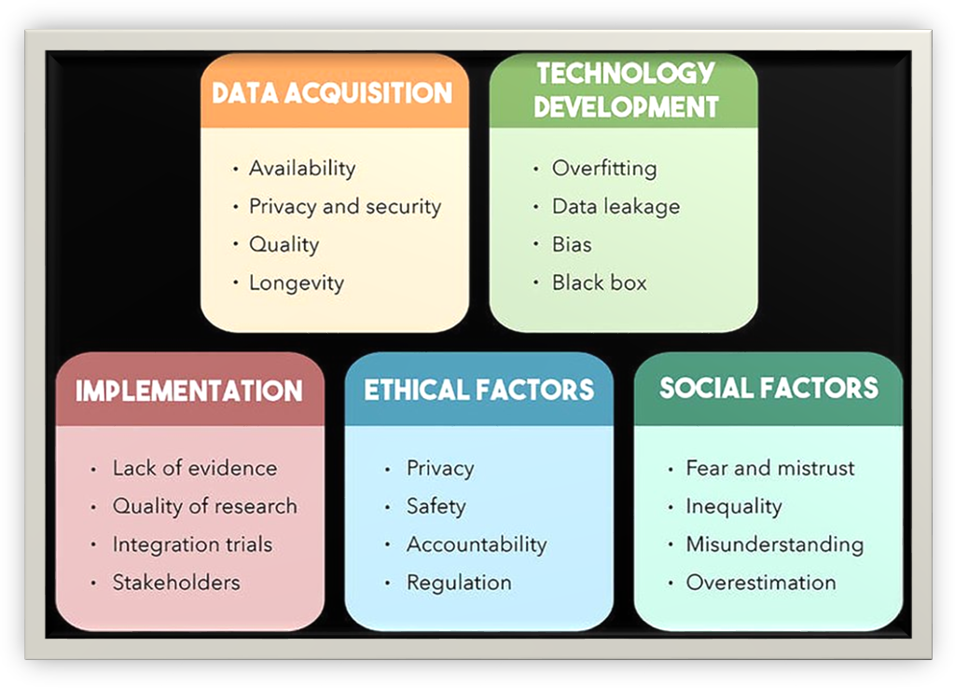

Sample example of code to diagnose the illness with limited inputs and output information :-

#include <iostream>
#include <string>
using namespace std;

int main()
{
string symptoms;
cout << "Please enter your symptoms (separated by commas): ";
getline(cin, symptoms);

if (symptoms.find("cough") != string::npos && symptoms.find("fever") != string::npos && symptoms.find("fatigue") != string::npos)
{
cout << "You may have the flu." << endl;
cout << "You can take Benadryl allergy plus congestion tablet or ibuprofen tablet " << endl;

cout << "You must consult healthcare professional if not cured at the earliest" << endl;
}
else if (symptoms.find("fever") != string::npos && symptoms.find("cough") != string::npos)
{
cout << "you may have common cold." << endl;
cout << "You can take Benadryl allergy plus congestion tablet or ibuprofen tablet " << endl;
cout << "You must consult healthcare professional if not cured at the earliest" << endl;
}
else if (symptoms.find("shortness of breath") != string::npos && symptoms.find("fatigue") != string::npos && symptoms.find("fever") != string::npos)
{
cout << "You may have COVID-19." << endl;
cout << "You are required to contact the healthcare professional at the earliest " << endl;
cout << "You must isolate yourself from other people and wear mask while meeting the hospital staff" << endl;
}
else if (symptoms.find("chest pain") != string::npos && symptoms.find("shortness of breath") != string::npos && symptoms.find("fatigue") != string::npos)
{
cout << "You may have heart disease." << endl;
cout << "Do you want to know more about heart attack :" << endl;
string s1;
cin >> s1;
if (s1 == "yes" || s1 == "Yes")
{
cout << "Tests to diagnose a heart attack include:" << endl;
cout << "Electrocardiogram (ECG or EKG), Blood tests, Coronary
catheterization (angiogram),Cardiac CT or MRI" << endl;
cout << "If you get positive test then consult the Doctor at the earliest " << endl;
}
else
{
cout << "Thank You for your time" << endl;
}
}
else if (symptoms.find("abdominal pain") != string::npos && symptoms.find("nausea") != string::npos && symptoms.find("vomiting") != string::npos)

{
cout << "You may have gastroenteritis." << endl;
cout << "You can tablets such as loperamide link (Imodium) and bismuth subsalicylate link" << endl;
cout << "If ypu don't get comfort then consult the doctor" << endl;
}
else if (symptoms.find("joint pain") != string::npos && symptoms.find("fatigue") != string::npos && symptoms.find("fever") != string::npos)
{
cout << "You may have rheumatoid arthritis.This is the most common problem among the people of age above 30" << endl;
cout << "This may include home treatment and clinical treatments" << endl;
cout << "Home remedies like heat and cold massage over joints, exercising regularly and relaxing" << endl;
cout << "For clinical treatment please consult the doctor because that will be given after few tests " << endl;
}
else if (symptoms.find("frequent urination") != string::npos && symptoms.find("increased thirst") != string::npos && symptoms.find("unexplained weight loss") != string::npos)
{
cout << "You may have diabetes." << endl;
cout << "You should consult a healthcare professional for diagnosis and treatment." << endl;
}
else
{
cout << "We're sorry, we could not determine your disease based on your symptoms. Please consult a healthcare professional for more information." << endl;
}

return 0;
}

Output of the above program based on the different inputs :-

PS C:\Users\user> cd "d:\sem4\artificial intelligence\" ; if ($?) { g++ p1.cpp -o p1 } ; if ($?) { .\p1 }
Please enter your symptoms (separated by commas): cough,fever,fatigue
You may have the flu.
You can take Benadryl allergy plus congestion tablet or ibuprofen tablet
You must consult healthcare professional if not cured at the earliest

PS D:\sem4\artificial intelligence> cd "d:\sem4\artificial intelligence\" ; if ($?) { g++ p1.cpp -o p1 } ; if ($?) { .\p1 }Please enter your symptoms (separated by commas): fever,cough
you may have common cold.
You can take Benadryl allergy plus congestion tablet or ibuprofen tablet
You must consult healthcare professional if not cured at the earliest

Please enter your symptoms (separated by commas): abdominal pain,nausea,vomiting
You may have gastroenteritis.
You can tablets such as loperamide link (Imodium) and bismuth subsalicylate link
If you don't get comfort then consult the doctor

PS D:\sem4\artificial intelligence> cd "d:\sem4\artificial intelligence\" ; if ($?) { g++ p1.cpp -o p1 } ; if ($?) { .\p1 }
Please enter your symptoms (separated by commas): joint pain,fatigue,fever
You may have rheumatoid arthritis.This is the most common problem among the people of age above 30
This may include home treatment and clinical treatments
Home remedies like heat and cold massage over joints, exercising regularly and relaxing
For clinical treatment please consult the doctor because that will be given after few tests

PS D:\sem4\artificial intelligence> cd "d:\sem4\artificial intelligence\" ; if ($?) { g++ p1.cpp -o p1 } ; if ($?) { .\p1 }
Please enter your symptoms (separated by commas): frequent urination,increased thirst,unexplained weight loss

You may have diabetes.
You should consult a healthcare professional for diagnosis and treatment.

PS D:\sem4\artificial intelligence> cd "d:\sem4\artificial intelligence\" ; if ($?) { g++ p1.cpp -o p1 } ; if ($?) { .\p1 }
Please enter your symptoms (separated by commas): chest pain,shortness of breath,fatigue
You may have heart disease.
Do you want to know more about heart attack :
yes
Tests to diagnose a heart attack include:
Electrocardiogram (ECG or EKG), Blood tests, Coronary catheterization (angiogram),Cardiac CT or MRI
If you get positive test then consult the Doctor at the earliest

PS D:\sem4\artificial intelligence> cd "d:\sem4\artificial intelligence\" ; if ($?) { g++ p1.cpp -o p1 } ; if ($?) { .\p1 }
Please enter your symptoms (separated by commas): shortness of breath,fatigue,fever
You may have COVID-19.
You are required to contact the healthcare professional at the earliest
You must isolate yourself from other people and wear mask while meeting the hospital staff

PS D:\sem4\artificial intelligence> cd "d:\sem4\artificial intelligence\" ; if ($?) { g++ p1.cpp -o p1 } ; if ($?) { .\p1 }
Please enter your symptoms (separated by commas): blurry eyes
We're sorry, we could not determine your disease based on your symptoms. Please consult a healthcare professional for more information.

Conclusion:-

The integration of Artificial Intelligence (AI) into healthcare has the potential to revolutionize the field and improve patient outcomes. AI has already demonstrated its value in numerous applications within the healthcare sector, including diagnostic accuracy, treatment plans, personalized medicine, and more. As the world becomes more complex and the demand for efficient and effective healthcare services increases, AI can offer new and innovative solutions to improve patient care, outcomes, and overall experience.

One of the key benefits of AI in healthcare is its ability to process vast amounts of data quickly and accurately. By analyzing data from electronic health records, medical imaging, and other sources, AI algorithms can identify patterns and insights that might otherwise go unnoticed. This can help healthcare providers to make more informed decisions and improve patient care.

AI has the potential to address some of the biggest challenges facing the healthcare industry today, including reducing medical errors, improving patient safety, and lowering healthcare costs. AI can help healthcare providers to make more accurate diagnoses, predict patient outcomes, and develop personalized treatment plans based on an individual's unique needs and medical history.

In addition to improving patient outcomes, AI can also streamline administrative tasks, freeing up healthcare providers to focus on patient care. This can include tasks such as appointment scheduling, insurance claims processing, and other administrative tasks. By automating these tasks, healthcare providers can improve efficiency and reduce costs.

One of the most exciting applications of AI in healthcare is the development of personalized medicine. By analyzing an individual's unique genetic makeup, medical history, and other factors, AI algorithms can develop personalized treatment plans that are tailored to each patient's specific needs. This can lead to more effective treatments, fewer side effects, and improved patient outcomes.

However, there are also challenges and potential drawbacks associated with AI in healthcare. One concern is the potential for AI algorithms to perpetuate bias, either through biased data or biased programming. Additionally, there are concerns around the ethical implications of using AI in healthcare, particularly with regards to patient privacy and informed consent.

Overall, the benefits of AI in healthcare are clear, and the field is likely to continue to grow and evolve in the coming years. As healthcare providers and technology companies work together to develop new applications and ensure that they are used ethically and responsibly, we can expect to see AI playing an increasingly important role in improving patient outcomes and transforming the healthcare industry as a whole.

In conclusion, AI is already transforming healthcare by providing valuable insights, improving patient outcomes, and reducing healthcare costs. The potential for AI in healthcare is vast, and the field is likely to continue to grow and evolve in the coming years. However, it is important to ensure that the technology is used ethically and responsibly, with a focus on improving patient care and outcomes. As AI becomes increasingly integrated into healthcare, it is important to ensure that all patients have access to these new and innovative technologies, regardless of their socioeconomic status or geographic location. With proper oversight and collaboration between healthcare providers and technology companies, AI has the potential to revolutionize healthcare and improve the lives of patients around the world.

References :-

- https://core.ac.uk/download/pdf/39667613.pdf
- https://www.ibm.com/in-en/topics/neural-networks
- https://www.javatpoint.com/linear-regression-in-machine-learning
- https://www.geeksforgeeks.org/ml-linear-regression/
- https://scikit-learn.org/stable/modules/svm.html
- https://www.sciencedirect.com/science/article/abs/pii/S0925231209001805
- https://otexts.com/fpp2/index.html
- https://data-flair.training/blogs/ai-in-healthcare-sector/
- https://www.microsoft.com/en-us/industry/blog/health/2019/02/25/ai-in-health-think-bigger-start-now-with-virtual-assistants/
- https://www.foreseemed.com/artificial-intelligence-in-healthcare
- https://www.ncbi.nlm.nih.gov/pmc/articles/PMC8754556/#:~:text=Artificial%20intelligence%20can%20assist%20providers,discovery%2C%20and%20patient%20risk%20identification.

